Civil war in Liberia

UNSC Resolution: | 1408
Date of adoption: | 6-May-2002
Operative paragraph: | 10
Demand number: | 1408,1011

Sarah-Myriam Martin-Brûlé

Wording of demand

take urgent steps, including through the establishment of transparent and internationally verifiable audit regimes, to ensure that revenue derived by the Government of Liberia from the Liberia Shipping Registry and the Liberian timber industry is used for legitimate social, humanitarian and development purposes, and is not used in violation of this resolution, and report back to the Committee on the steps taken and results of such audits not later than three months after the date of adoption of this resolution

List of addressees of the demand

Government of Liberia

Short-term compliance

Description of the addressee(s)’ conduct

“16. The Panel continued to investigate how the Government of Liberia funds its arms procurement. Nearly all income appears to be used for military operations and this pattern of spending has contributed towards humanitarian hardship. An independent audit of key revenue sources, such as those from the corporate and maritime registry and timber industry, remains pressing. In both cases, the Panel found evidence of discrepancies of millions of United States dollars between the figures provided by the Ministry of Finance and the Central Bank of Liberia or the Forestry Development Authority.
17. In a welcome move, the Government of Liberia signed on 27 September with the international auditing firm Deloitte & Touche for a systems audit and design aimed at capturing and tracking the revenue and expenditure of proceeds derived from maritime and forestry activities. This will only last for 120 days, however. The Panel recommends that the Government publish all of the results of this systems audit and that, once it is completed, it should be followed up with an 18-month full financial audit by an international auditing firm.
71. The Panel also met with Mr. Orhan Dragas, who had allegedly introduced the non-identified African clients to Mr. Tezic. Mr. Dragas acknowledged that he knew Mr. Tezic and had been contacted by him for a meeting with the Panel. When the Panel inquired about Mr. Dragas’s business, he explained that he was a trader in timber and cacao, although his business card mentions that he is President of the Board of a company MDO Systems “Trading Company for Special Purpose Merchandise”, an English translation of the Yugoslav terminology used to describe military equipment.
159. The Liberian economy is in crisis. Real gross domestic product is expected to contract in 2002 because of the disruption to economic activity caused by the war. This compares with an average annual growth rate of over 20 per cent in the period 1997-2000, when the economy rebounded from the 1989-1996 civil war. Although official exports grew in 2001 over those of 2000, this was mainly because of increased rubber production. The spread of the war has impacted upon rubber, timber and diamond production. Timber, rubber, maritime and taxation of imports remain the key sources of revenue generation in Liberia. According to the Forestry Development Authority, 75 per cent of timber concessions are currently inactive. However, a few major timber companies, such as the Oriental Timber Company, dominate the timber industry and they remain active.
189. In its previous reports (S/2001/1015 and S/2002/470), the Panel examined the timber industry and documented in one case how it had provided funds for weapons. Logging activities in 2002 continue to be one of the few areas of revenue growth, although the war in Lofa county had badly affected timber production. Because of the seasonal rains during the reporting period, logging production has been low.
190. According to the most recent figures of the Central Bank of Liberia, round logs valued at US$ 59.5 million were exported from Liberia in 2001. By March 2002, log exports were officially accounted at US$ 4,674,000. Sawn timber only figured at US$ 510,000. The Panel in the past has reported the irregularity of figures from the timber industry. In September, the Liberian non-governmental organization, Save My Future Foundation, published a comparative analysis of timber production and timber assessed revenue from 1997 to 2001, which showed a massive discrepancy for a massive number of round logs unaccounted for. 191. A comparison of the export figures of the Central Bank of Liberia with the figures of the Forestry Development Authority indicate a significant discrepancy of US$ 6 million in 2000 and US$ 19,610,000 in 2001.
192. The Forestry Development Authority was last audited by the Auditor General in 1994. The strategic importance of logging continues to be shown by the fact that the Authority remains outside the centralized revenue account of the Government of Liberia Tax Account at the Central Bank. This is despite instructions issued by the Central Bank of Liberia and the Ministry of Finance in June 2002 and contrary to the information provided by the Government to the Security Council Committee on Liberia. The consolidation of this timber revenue into one government account was also a recommendation of the Panel (see S/2002/470) and a request by IMF on a regular basis, most recently after the conclusion of its article IV consultations in 2002.
United Nations Security Council. Report of the Panel of Experts appointed pursuant to Security Council resolution 1408 (2002), paragraph 16, concerning Liberia. S/2002/1115
http://www.reliefweb.int/rw/RWFiles2002.nsf/FilesByRWDocUnidFilename/O CHA-64CUBY-unsc-lib-25oct.pdf/$File/unsc-lib-25oct.pdf

Assessment

Short-term compliance
X No or marginal compliance (1) | Medium low compliance (2) | Medium high compliance (3) | Full or almost full compliance (4)

Considerations underlying the assessment

The Government of Liberia did not take urgent steps, including through the establishment of transparent and internationally verifiable audit regimes, to ensure that revenue derived by the Government of Liberia from the Liberia Shipping Registry and the Liberian timber industry was used for legitimate social, humanitarian and development purposes. The government failed to report back to the Committee on the steps taken and results of such audits not later than three months after the date of adoption of this resolution

Medium-term compliance

Description of the addressee(s)’ conduct
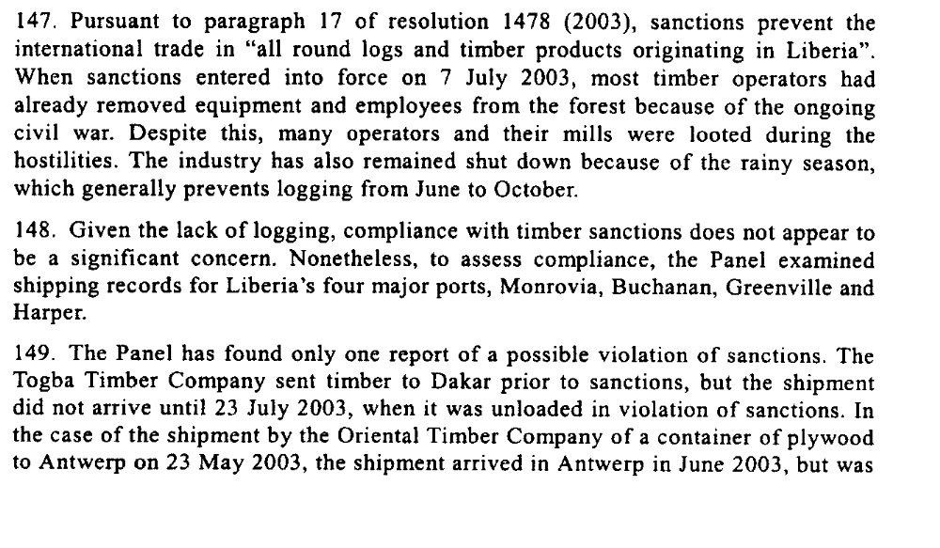
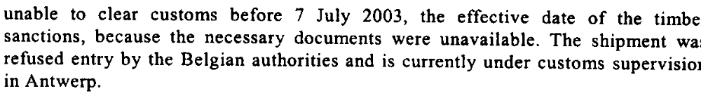

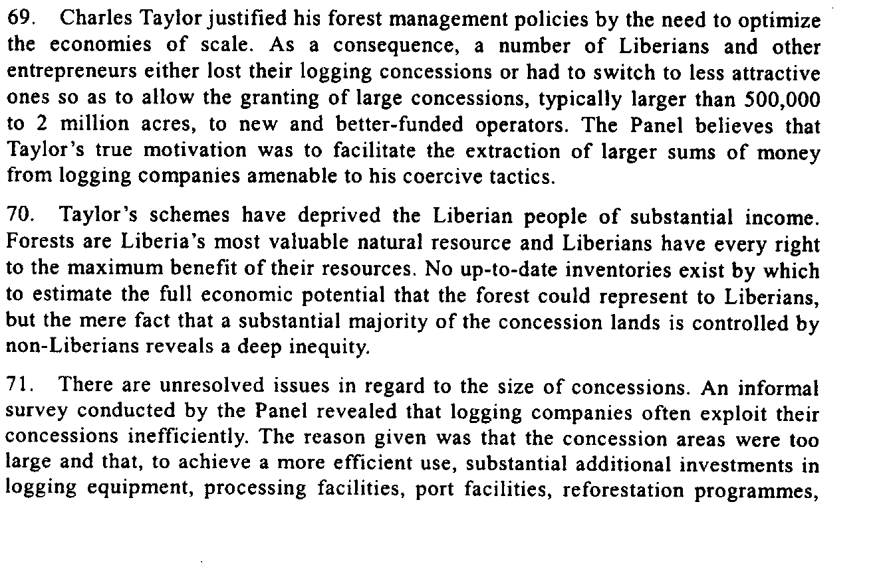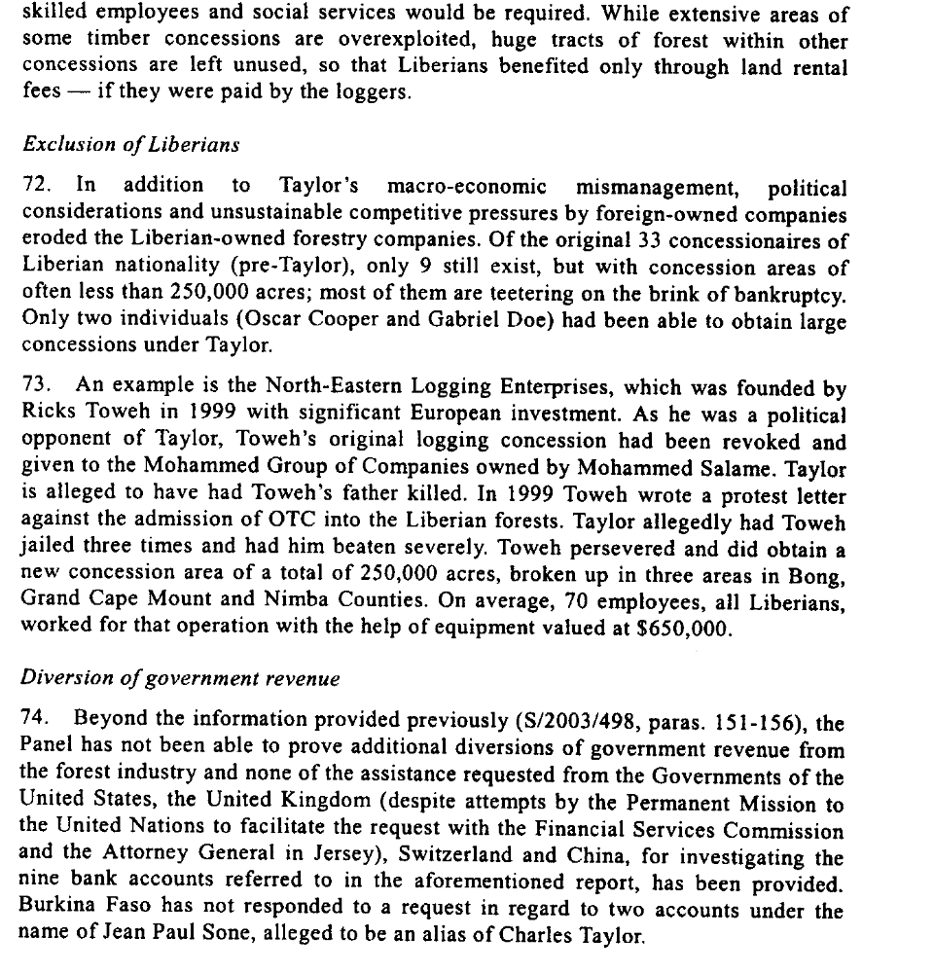

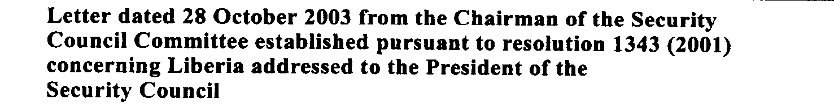

There are continued reports of poor management and corruption within the NTGL, and the government’s failure to function effectively has delayed donor aid and debt restructuring. The NTGL’s continued refusal to fully and publicly account for the handling of large resource deals, such as the US$10 million sale of iron ore to a Chinese company, has further undermined public and international confidence in the government’s commitment to operate in a transparent and accountable manner.

33. The negative humanitarian and social effects of the timber industry include
(a) rapid destruction of Liberia’s forest resources, a key national economic asset,
because of overexploitation and uncontrolled logging practices; (b) disruption of
traditional forest-dwelling communities; (c) reported deplorable and even dangerous
working conditions for timber workers; (d) reported sexual exploitation of women
and teenage girls in communities surrounding logging camps; and (e) the provision
of direct access to previously remote forest areas, which has resulted in a sharp
increase in commercial hunting.
34. Furthermore, it has been alleged that certain actors involved in the timber
industry have actively supported armed groups engaged in the conflict, whether by
providing transport for or actual weapons; by providing funding to parties to the
conflict; or by supporting independent militia groups. This raises questions
regarding the role of the timber industry which have yet to be fully investigated.
Moreover, the Panel of Experts on Liberia found that some of the timber companies
active during 2001 were directly involved in violations of sanctions imposed by
Security Council resolution 1343 (2001) (see S/2001/1015).
35. Several survey respondents independently confirmed the assertion that the
logging industry does indeed represent an important source of employment in rural
areas of Liberia, but that the primary benefits afforded to rural communities were
the provision of road access, markets for their goods and some limited social
services. At least two logging companies were reported to provide such limited
social services. The Oriental Timber Company provided fee-based healthcare for
workers, and support for the Buchanan hospital, and the Maryland Wood Processing
Industries provided a school and clinic in Grebo National Forest.

41. Previous sections of this report have highlighted the contribution of timber revenues to GDP and export earnings. In terms of government revenue, the timber industry paid $8.4 million to the Government of Liberia in 2001, and an estimated $13 million in 2002. The elimination of this source of revenue would have constituted a 12 per cent and an 18
per cent reduction in government revenue for 2001 and 2002, respectively.

Report of the Secretary-General in pursuance of paragraph 19 of resolution 1478 (2003) concerning Liberia

18. The entire six-member Panel met for the first time on 14 June 2003 in New
York. The consultant for humanitarian and socio-economic aspects joined the Panel
in Abidjan. Significant time constraints and security restrictions in Liberia limited
the Panel’s investigation. In addition, insufficient credible data on Liberia’s timber
industry as well as on the country’s humanitarian and socio-economic situation has
hampered the investigation.

33. Liberia generally lacks transparency in governance, and trade data are
unreliable and conflicting. One official source, FDA, reported exports of
approximately $80 million for 2001, with assessed taxes of approximately $19
million. The Intelligence Unit of The Economist magazine estimated that forestry
accounted for 22 per cent of the gross domestic product of Liberia.
34. Since July 2003, the timber industry has been sanctioned by the Security
Council to deprive the Government of Liberia of a significant source of revenue,
which President Taylor admits has been used to purchase arms in violation of
resolution 1343 (2001) (according to media interviews on 28 March and 2 April
2003). Civil society groups have alleged that Liberian timber companies are linked
to the illegal arms trade.

70. Given that the Government of Liberia has failed to demonstrate how timber
revenue is used, it must be assumed that it and non-State actors will continue to
exploit the resource to foment conflict. The collapse of peacekeeping in Liberia in
1996 was linked to the efforts of combatants to gain revenue from natural
resources.1 Letters sent to environmental NGOs and people interviewed by the Panel
of Experts suggest that MODEL wants to engage loggers to exploit timber illegally.

86. Reform will require opening the sector to public scrutiny. The Government of
Liberia should immediately submit to a full financial audit of FDA as required in
paragraph 10 of Security Council resolution 1408 (2002). The complete results must
be made public.

90. FDA admits that it does not have the capacity to monitor and police the
industry. There has been little political will within the Government to see that the
laws and regulations of Liberia are enforced. Without enforcement, and with widespread illegal activity, it becomes difficult for legitimate operators to compete.
It is a classic case of the concurrent failure of the Government and the market.2
91. The Government of Liberia must give FDA adequate resources and equipment
to fulfil its mandate. In particular, officials require vehicles to inspect logging sites.
(At present, FDA relies on logging companies to provide transportation — a clear
conflict of interest.)
92. The Government of Liberia and FDA should continue to develop Liberian
management capacity by providing staff with training and by sponsoring students at
the University of Liberia.
93. Until legal wood can be segregated from illegal wood, it must be assumed that
illegal wood will enter the supply chain and that combatants may gain revenue from
the illegal exploitation of timber resources. To segregate wood, timber companies
must maintain a chain of custody of all harvested logs, from the concession through
processing to the point of export (see box 3). To ensure that they are not in receipt of
illegally harvested timber, international buyers, such as Pinault Bois et Materiaux,
DLH Nordisk A/S and Global Star (Asia) Trading Ltd., should demand that
producers demonstrate a legal chain of custody.

United Nations Security Council. Letter dated 7 August 2003 from the Acting Chairman of the Security Council Committee established pursuant to resolution 1343 (2001) concerning Liberia addressed to the President of the Security Council

“High profile incidents, such as the multi-million dollar purchase of luxury jeeps for government ministers, have concerned donors and angered Liberians desperate for the NTGL to spend its resources on more pressing matters. This lack of financial control has caused many international donors to withhold aid that was pledged at the Liberia Donors Conference in February 2004, and may impede IMF plans to restructure Liberia’s US$3 billion in international debt41. While the NTGL appears to be responding previous attempts to stamp out corruption have not worked. Donors should place more pressure on the NTGL to improve its governance, conditioning their aid with requirements of transparency and accountability to ensure money is not misappropriated.”
Global Witness Report 2004. “Dangerous Liaisons The continued relationship between Liberia’s natural resource industries, arms trafficking and regional insecurity”. 8 December . A briefing document submitted by Global Witness to the UN Security Council.
http://www.globalwitness.org/media_library_detail.php/128/en/dangerous_liaisons

Assessment

Medium-term compliance
X No or marginal compliance (1) | Medium low compliance (2) | Medium high compliance (3) | Full or almost full compliance (4)

Considerations underlying the assessment

Within the two years following the adoption of the resolution, the government failed to take urgent steps, including through the establishment of transparent and internationally verifiable audit regimes, to ensure that revenue derived by the Government of Liberia from the Liberia Shipping Registry and the Liberian timber industry was used for legitimate social, humanitarian and development purposes. There has been further evidence that it was not used in violation of this resolution, and the government failed to report back to the Committee on the steps taken and results of such audits.

Depth of demand

Assessment

Level of depth of demand
Low depth of demand (1) | X Medium depth of demand (2) | High depth of demand (3)

Considerations underlying the assessment

“Timber revenues are routinely siphoned off for extra-budgetary expenditures by the
government, and are not channelled through the central bank to be spent on
legitimate development. Logging companies, if and when they pay duties to
the government, routinely do so as a mixed percentage of cash and illicit weapons,
thereby remilitarising the country and increasing the proliferation of armed
combatants. »
Global Witness Report. 2003. “The Usual Suspects Liberia’s Weapons and Mercenaries in Côte d’Ivoire and Sierra Leone : Why it’s Still Possible, How it Works and How to Break the Trend” . 31 March.

http://www.reliefweb.int/rw/RWFiles2003.nsf/FilesByRWDocUNIDFileName/ACOS-64CNHR-gw-lbr-31mar.pdf/$File/gw-lbr-31mar.pdf

“Liberia’s continued access to illegal arms and mercenaries is due to the availability of funds and logistics provided by the Liberian timber industry. The omission of timber sanctions in Resolution 1343 (2001) Adopted by the Security Council at its 4287th meeting, on 7 March 2001e and Resolution 1408 (2002) Adopted by the Security Council at its 4526th meeting, on 6 May 2002f has allowed Liberia to maintain regular imports of arms and cash to pay both its domestic security forces and the mercenaries recruited for Côte d’Ivoire and Sierra Leone.”

Global Witness Report. 2003. “The Usual Suspects Liberia’s Weapons and Mercenaries in Côte d’Ivoire and Sierra Leone : Why it’s Still Possible, How it Works and How to Break the Trend” . 31 March.

Level of confidence about coding decisions

Level of confidence about coding decision
Extremely high | X High | Moderate

Comments to IPI (if any)

According to Global Witness:

Like the DRC Reports, the Liberia reports "name and shame" some government officials
and well-known international criminals such as Leonid Minin. However, given that the focus of these reports is not on natural resource exploitation, the reports fail to properly
investigate whether there are "elite networks" controlling the illegal exploitation of resources in Liberia.
Global Witness Report. 2003. “The Usual Suspects Liberia’s Weapons and Mercenaries in Côte d’Ivoire and Sierra Leone : Why it’s Still Possible, How it Works and How to Break the Trend” . 31 March.

http://www.reliefweb.int/rw/RWFiles2003.nsf/FilesByRWDocUNIDFileName/ACOS-64CNHR-gw-lbr-31mar.pdf/$File/gw-lbr-31mar.pdf

